Similarities

[tl;dr](https://docs.cs50.net/2019/x/psets/7/similarities/similarities.html#tldr)

1. Implement a program that compares two files for similarities.
2. Implement a website that highlights similarities across files, a la the below.

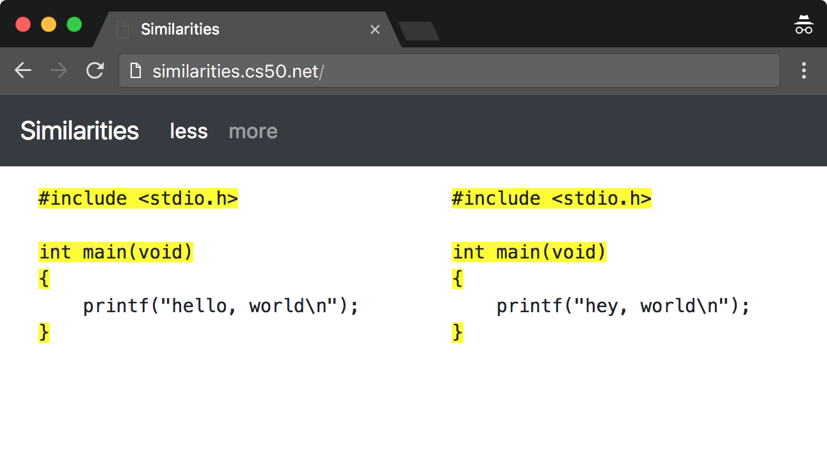

[Background](https://docs.cs50.net/2019/x/psets/7/similarities/similarities.html#background)

Determining whether two files are identical is (relatively!) trivial: iterate over the characters in each, checking whether each and every one is identical. But determining whether two files are similar is non-trivial. After all, what does it mean to be similar? Perhaps the files have lines in common. Perhaps the files have sentences in common. Perhaps the files have only substrings in common.

Suffice it to say, the challenge ahead is to determine if two files are similar!

[Getting Started](https://docs.cs50.net/2019/x/psets/7/similarities/similarities.html#getting-started)

Here’s how to download this problem’s "distribution code" (i.e., starter code) into your own CS50 IDE. Log into [CS50 IDE](https://ide.cs50.io/) and then, in a terminal window, execute each of the below.

1. Execute cd to ensure that you’re in ~/ (aka your home folder).
2. Execute mkdir pset7 to make (i.e., create) a directory called pset7 in your ~/ directory, if you haven’t already done so.
3. Execute cd pset7 to change into (i.e., open) that directory.
4. Execute wget <https://cdn.cs50.net/2018/fall/psets/7/similarities/similarities.zip> to download a (compressed) ZIP file with this problem’s distribution.
5. Execute unzip similarities.zip to uncompress that file.
6. Execute rm similarities.zip followed by yes or y to delete that ZIP file.
7. Execute ls. You should see a directory called similarities, which was inside of that ZIP file.
8. Execute cd similarities to change into that directory.
9. Execute ls. You should see this problem’s distribution inside: ` application.py compare* helpers.py inputs/ requirements.txt static/ templates/ `

[Understanding](https://docs.cs50.net/2019/x/psets/7/similarities/similarities.html#understanding)

[inputs/](https://docs.cs50.net/2019/x/psets/7/similarities/similarities.html#inputs)

Inside of this directory are a whole bunch of sample inputs that you can ultimately compare, among others, for similarities!

[compare](https://docs.cs50.net/2019/x/psets/7/similarities/similarities.html#compare)

Open up compare. Suffice it to say that file’s name doesn’t end in .py, even though the file contains a program written in Python. But that’s okay! Notice the "shebang" atop the file:

#!/usr/bin/env python3

That line tells a computer to interpret (i.e., run) the program using python3 (aka python on CS50 IDE), an interpreter that understands Python 3.

Notice how the file defines a function called main and calls that function toward the bottom of the file. Defining main isn’t strictly necessary in Python, but it is necessary to define functions before you call them. Accordingly, because main calls a function called positive, and because we wanted to keep the "main" part of this program atop the file, it made sense to implement main as a function as well. That way, main doesn’t get called until the bottom of the file (after positive has been implemented), even though main is implemented atop the file.

No need to understand each of the lines in compare, but notice, per its comments, what it does overall: it parses its command-line arguments, reads two files into variables as strings, and compares those strings, and then prints a list of similarities. The strings themselves are compared in one of three ways, as specified by a command-line argument: line by line, sentence by sentence, or substring by substring.

[helpers.py](https://docs.cs50.net/2019/x/psets/7/similarities/similarities.html#helpers-py)

Open up helpers.py. Ah, the familiar TODO. Declared in this file are three functions, each of which is meant to implement a different algorithm: lines, sentences, and substrings. At the moment, each of them returns an empty list. But not for long!

[application.py](https://docs.cs50.net/2019/x/psets/7/similarities/similarities.html#application-py)

Open up application.py. This file implements a web application that, ultimately, will allow you to run any of those three algorithms on any two text files. No need to understand the entirety of this file, particularly highlight and errorhandler. But know that highlight, given a string, s, and a list of other strings, strings, highlights (by wrapping them in HTML span tags) all instances of the former in the latter. And errorhandler ensures that any HTTP errors are displayed on a page of their own.

But do read through index and compare, the latter of which handles form submissions.

[templates/layout.html](https://docs.cs50.net/2019/x/psets/7/similarities/similarities.html#templateslayout-html)

Open up templates/layout.html. In this file is a template for the web application’s overall layout. Odds are you’ll recognize a few of the HTML tags therein and notice a few new ones. Notice, in particular, how the template uses Bootstrap, a popular library. In fact, we based this template on their own [starter template](http://getbootstrap.com/docs/4.0/getting-started/introduction/).

[templates/index.html](https://docs.cs50.net/2019/x/psets/7/similarities/similarities.html#templatesindex-html)

Open up templates/index.html. Ah, the final TODO. Notice how this template "extends" layout.html, which is to say that layout.html is the "mold" from which index.html itself will be made. The block defined in index.html will effectively get plugged into the placeholder for block in layout.html.

Ultimately, this file will contain the form via which users will be able to upload two files to your web application for comparison via one of your three algorithms.

[templates/compare.html](https://docs.cs50.net/2019/x/psets/7/similarities/similarities.html#templatescompare-html)

Open up templates/compare.html. We took the liberty of implementing this file for you. Thanks to its use of some CSS (particularly a class called col-6), it ensures that users' files, once uploaded and highlighted, will be displayed side by side.

[templates/error.html](https://docs.cs50.net/2019/x/psets/7/similarities/similarities.html#templateserror-html)

Open up templates/error.html. In this file is a template with which any HTTP errors will be displayed. It happens to use Bootstrap’s [Jumbotron](https://getbootstrap.com/docs/4.0/components/jumbotron/) feature.

[static/styles.css](https://docs.cs50.net/2019/x/psets/7/similarities/similarities.html#staticstyles-css)

Open up static/styles.css. In this file are some CSS properties that collectively implement your web application’s user interface. Essentially, they modify some of Bootstrap’s own defaults.

[requirements.txt](https://docs.cs50.net/2019/x/psets/7/similarities/similarities.html#requirements-txt)

Open up requirements.txt (without changing it, though you can later if you’d like). This file specifies the libraries, one per line, on which all of this functionality depends.

[Specification](https://docs.cs50.net/2019/x/psets/7/similarities/similarities.html#specification)

[helpers.py](https://docs.cs50.net/2019/x/psets/7/similarities/similarities.html#helpers-py-2)

[lines](https://docs.cs50.net/2019/x/psets/7/similarities/similarities.html#lines)

Implement lines in such a way that, given two strings, a and b, it returns a list of the lines that are, identically, in both a and b. The list should not contain any duplicates. Assume that lines in a and b will be be separated by \n, but the strings in the returned list should not end in \n. If both a and b contain one or more blank lines (i.e., a \n immediately preceded by no other characters), the returned list should include an empty string (i.e., "").

[sentences](https://docs.cs50.net/2019/x/psets/7/similarities/similarities.html#sentences)

Implement sentences in such a way that, given two strings, a and b, it returns a list of the *unique* English sentences that are, identically, present in both a and b. The list should not contain any duplicates. Use sent_tokenize from the Natural Language Toolkit to "tokenize" (i.e., separate) each string into a list of sentences. It can be imported with:

from nltk.tokenize import sent_tokenize

Per its [documentation](http://www.nltk.org/api/nltk.tokenize.html#nltk.tokenize.sent_tokenize), sent_tokenize, given a str as input, returns a list of English sentences therein. It assumes that its input is indeed English text (and not, e.g., code, which might coincidentally have periods too).

[substrings](https://docs.cs50.net/2019/x/psets/7/similarities/similarities.html#substrings)

Implement substrings in such a way that, given two strings, a and b, and an integer, n, it returns a list of all substrings of length n that are, identically, present in both a and b. The list should not contain any duplicates.

Recall that a substring of length n of some string is just a sequence of n characters from that string. For instance, if n is 2 and the string is Yale, there are three possible substrings of length 2: Ya, al, and le. Meanwhile, if n is 1 and the string is Harvard, there are seven possible substrings of length 1: H, a, r, v, a, r, and d. But once we eliminate duplicates, there are only five unique substrings: H, a, r, v, and d.

[templates/index.html](https://docs.cs50.net/2019/x/psets/7/similarities/similarities.html#templatesindex-html-2)

Implement templates/index.html in such a way that it contains an HTML form via which a user can submit:

* a file called file1
* a file called file2
* a value of lines, sentences, or substrings for an input called algorithm
* a number called length

You’re welcome to look at the HTML of the staff’s solution as needed, but do try to figure out the right syntax on your own first, as via <https://www.google.com/search?q=html+forms!>

[Walkthroughs](https://docs.cs50.net/2019/x/psets/7/similarities/similarities.html#walkthroughs)

<https://youtu.be/JlGPuG6fIXs?list=PLhQjrBD2T382DOV8V9pWN7NTp0uRLvIYa>

[Testing](https://docs.cs50.net/2019/x/psets/7/similarities/similarities.html#testing)

To test your implementation of lines, sentences, and/or substrings via the command line, execute compare as follows, where FILE1 and FILE2 are any two text files (e.g., those in inputs/):

./compare --lines FILE1 FILE2

./compare --sentences FILE1 FILE2

./compare --substrings 1 FILE1 FILE2

./compare --substrings 2 FILE1 FILE2

...

To test your implementations via a web app, execute

flask run

and then visit the outputted URL.

Be sure to test your implementation with the files in inputs/ (which are also available [via a browser](https://cdn.cs50.net/2018/fall/psets/7/similarities/similarities/inputs/)) as well as with some files of your own!

[check50](https://docs.cs50.net/2019/x/psets/7/similarities/similarities.html#check50)

check50 cs50/problems/2019/x/similarities

[style50](https://docs.cs50.net/2019/x/psets/7/similarities/similarities.html#style50)

style50 helpers.py

[Staff’s Solution](https://docs.cs50.net/2019/x/psets/7/similarities/similarities.html#staffs-solution)

[CLI](https://docs.cs50.net/2019/x/psets/7/similarities/similarities.html#cli)

~cs50/2019/x/pset7/compare

[Web](https://docs.cs50.net/2019/x/psets/7/similarities/similarities.html#web)

<http://similarities.cs50.net/less>

[How to Submit](https://docs.cs50.net/2019/x/psets/7/similarities/similarities.html#how-to-submit)

Execute the below from within your ~/pset7/similarities directory, logging in with your GitHub username and password when prompted. For security, you’ll see asterisks (*) instead of the actual characters in your password.

submit50 cs50/problems/2019/x/similarities